**CHAPTER V**

**Results and Discussion**

**5.1 Development Phase**

The development phase of the system was scheduled in a timeline given to us by the programmers. Started off with the manifestation and refinement of the proposed database. Following the creation of the database, the programmers selected a pre-built or existing framework of a website that best suited our system’s needs. Following the framework selection and reconfiguration, the programmers started creating the graphical user interfaces without its functions and links enabled. After the altering of the objects in all the UIs of the users, they began to code the functions and processes that is required to majority of the objects to function. While the interfaces are undergoing its development, the programmers slowly integrate them accordingly by the system’s hierarchal levels. They did various testing, most of which they followed from the functional test of our proposed system in our documentation. Once some the functions of each page of various users are working, the programmers uploaded the website in their company’s host server. As the development phase went along the timeline, with some minor setbacks or delays, the programmers managed to hasten the development with borrowed time due to the critical changes and requirements that are required by the proponents for the system to be mostly presentable with majority of the functions working regardless of the delay of the aesthetics upgrade to the website. Alpha testing was later conducted by the programmers and proponents for the checking of the requirements of the system.

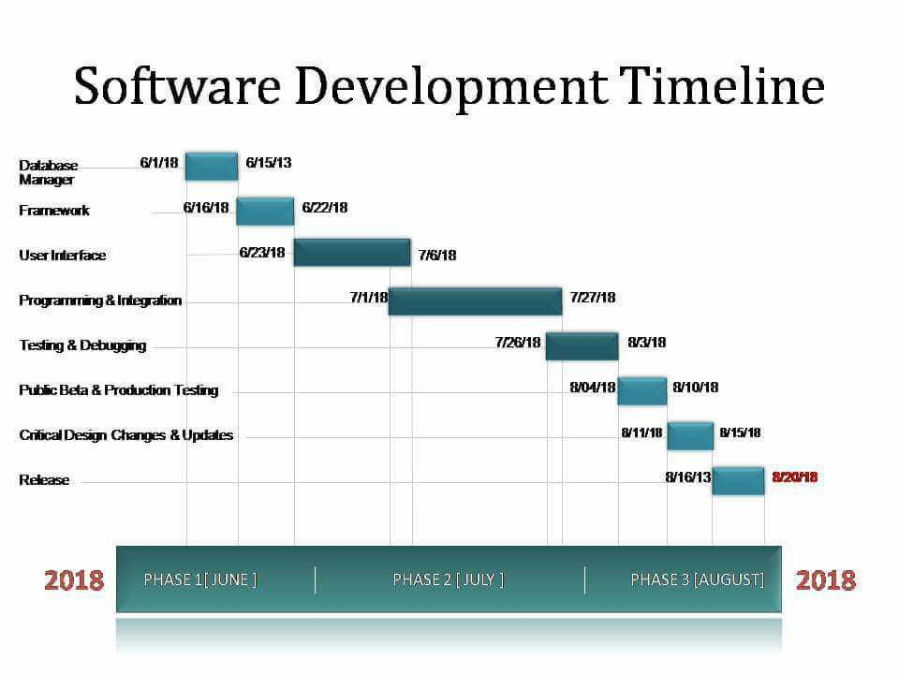

**Figure 5.1 Given Software Development Timeline**



**Figure 5.2 Proposed Login Page**

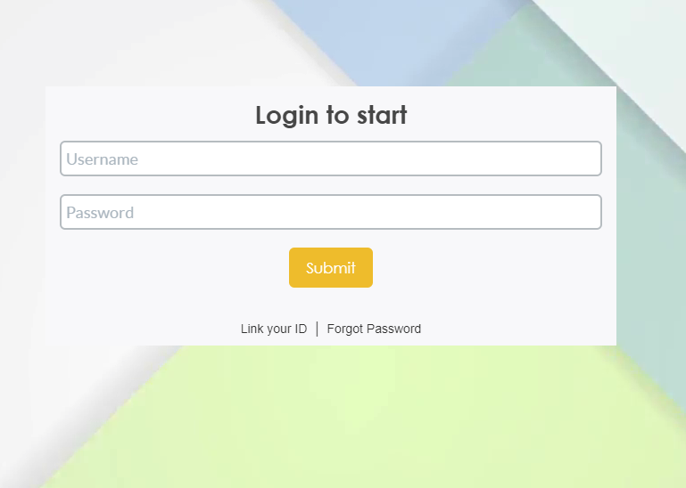  
**Figure 5.3 Revised Login Page**

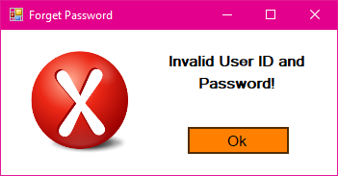

**Figure 5.4 Proposed Popup for Invalid Log in Information**

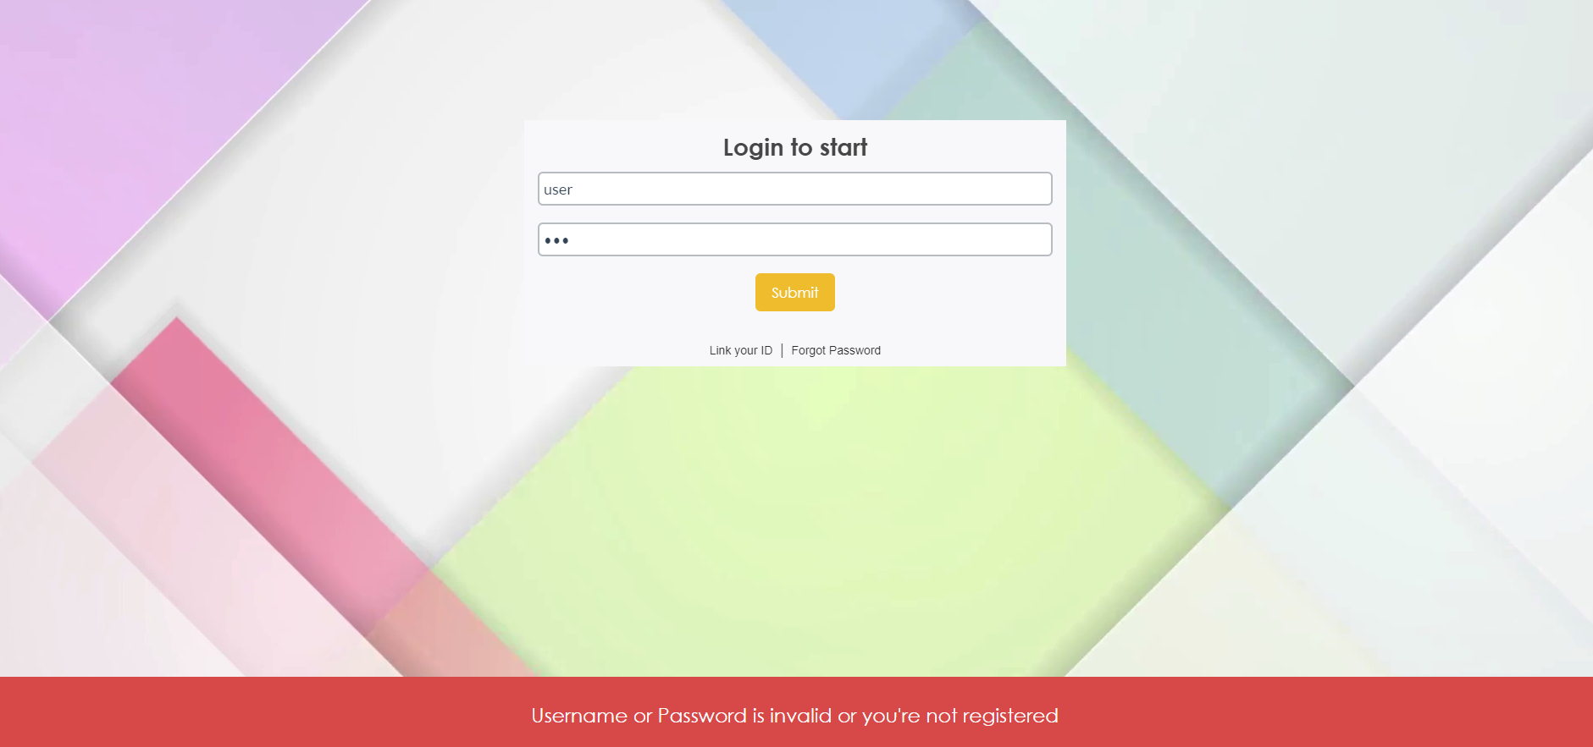  
**Figure 5.5 Revised Popup for Invalid Log in Information**

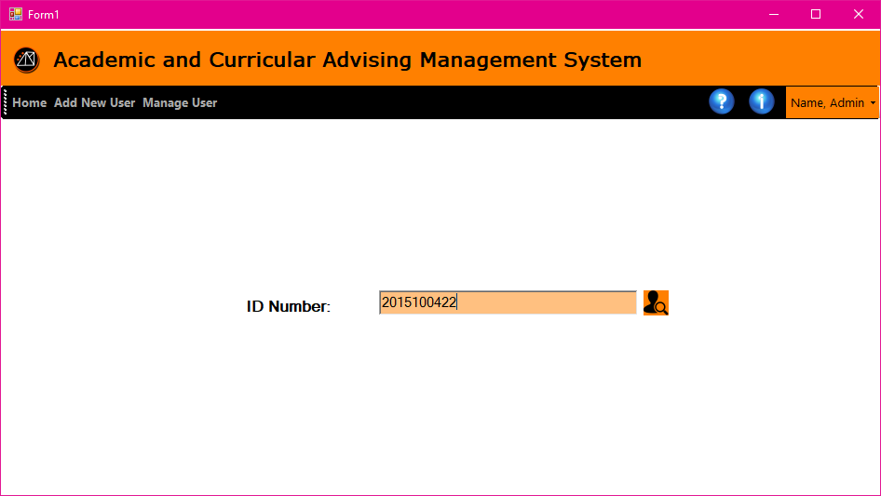

**Figure 5.6 Proposed Account Recovery**

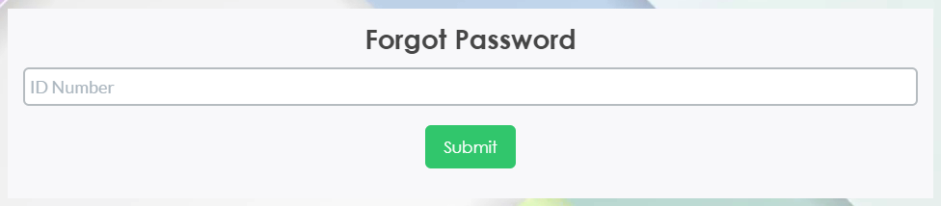

**Figure 5.7 Revised Account Recovery**

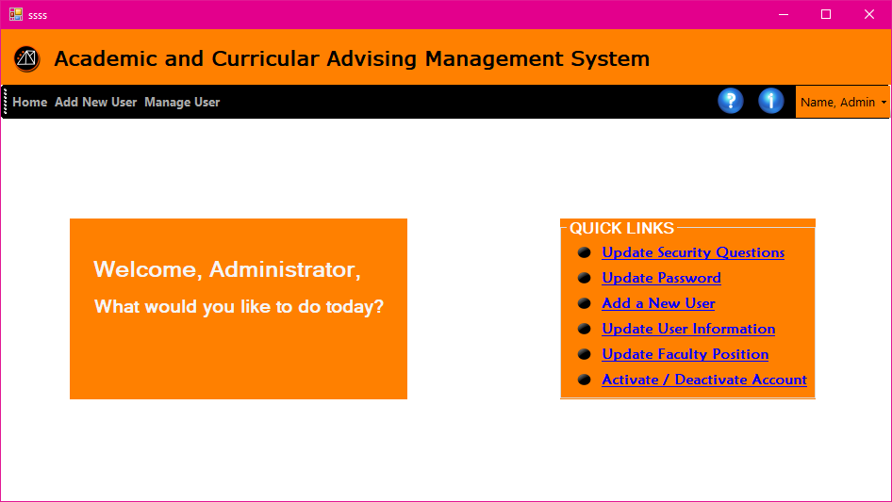

**Figure 5.8 Proposed Admin Homepage**

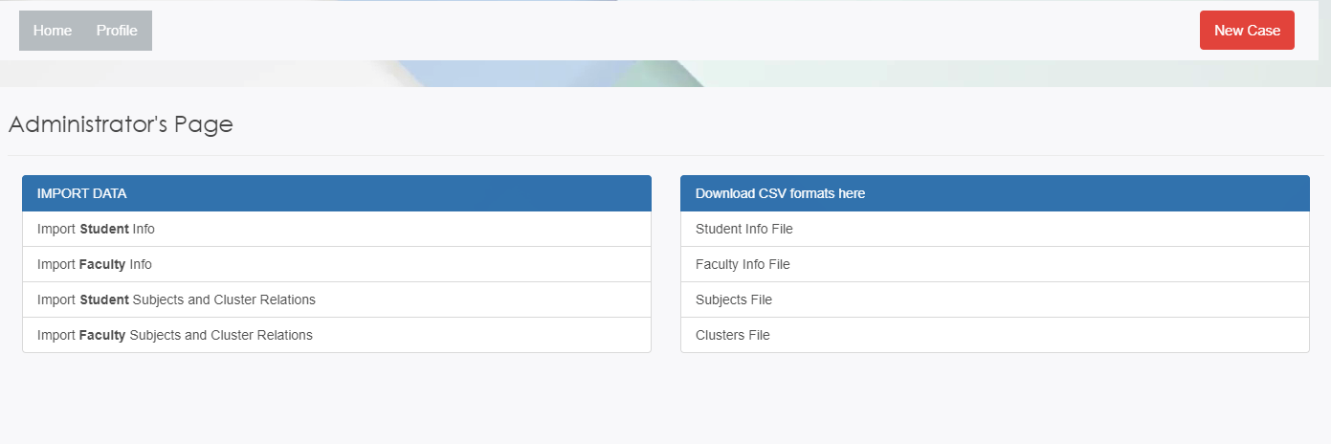  
**Figure 5.9 Revised Admin Page**

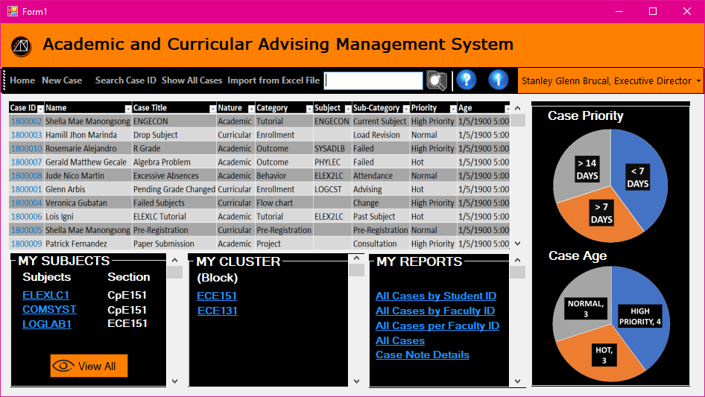

**Figure 5.10 Proposed User Homepage**

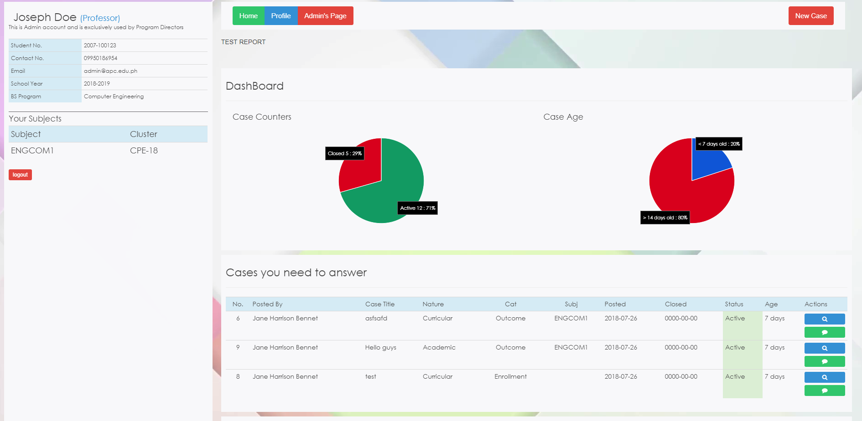

**Figure 5.11 Revised User Homepage**

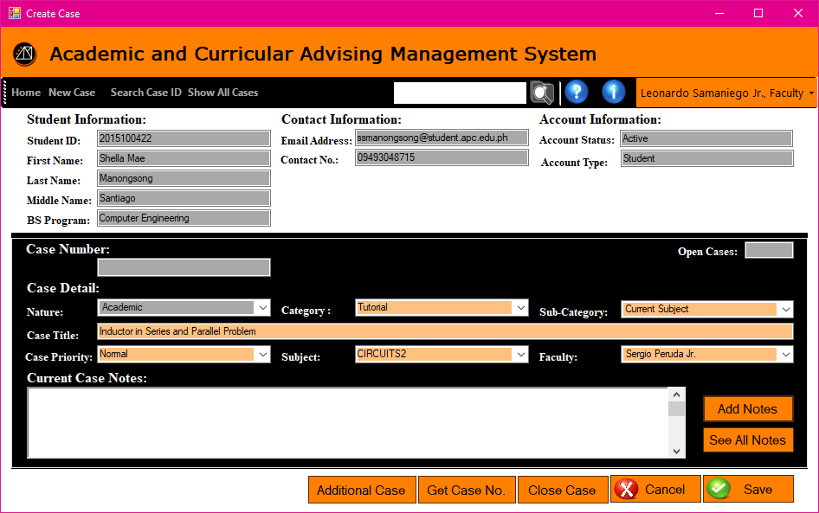

**Figure 5.12 Proposed Case Page**

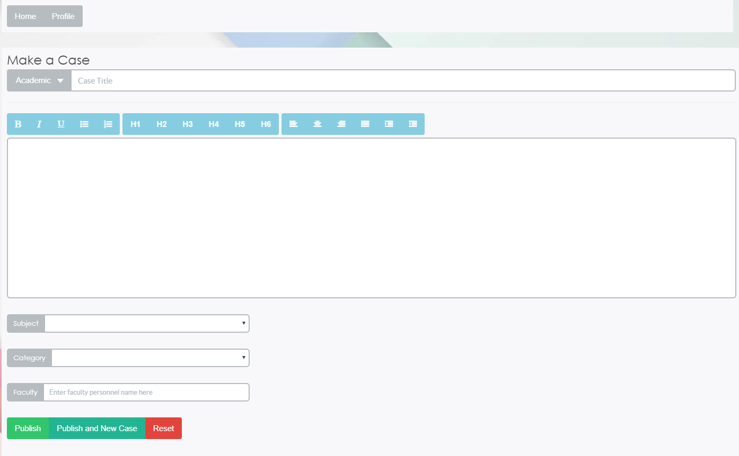

**Figure 5.13 Revised Case Page**

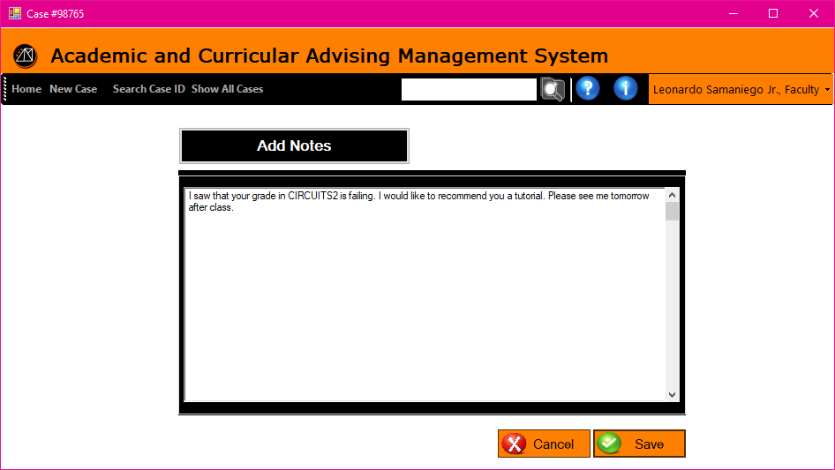

**Figure 5.14 Proposed Case Notes Page (Add Notes)**

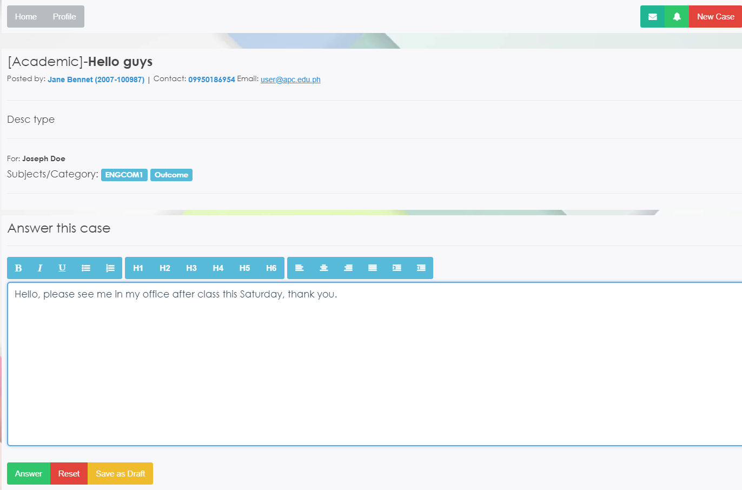

**Figure 5.15 Revised Case Notes Page (Add Notes)**



**Figure 5.16 Proposed Global Search Bar**

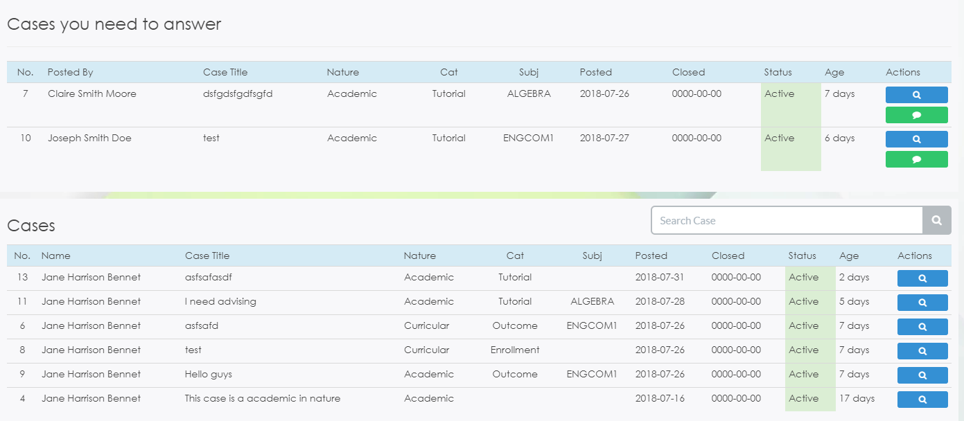

**Figure 5.17 Revised Global Search Bar**

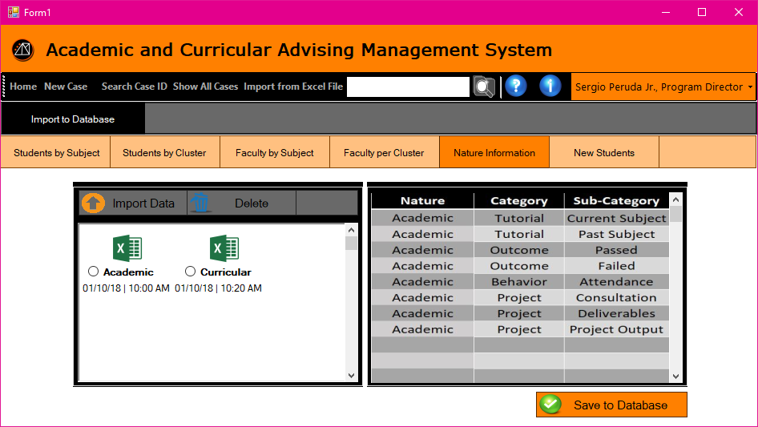

**Figure 5.18 Proposed Import Page**



**Figure 5.19 Revised Import Page**

**5.2 System Test**

**Table 5.1**

|  |  |  |
| --- | --- | --- |
| **Case** | **Script** | **Results** |
|  |  |  |
|  |  |  |
|  |  |  |
|  |  |  |
|  |  |  |
|  |  |  |
|  |  |  |
|  |  |  |
|  |  |  |
|  |  |  |
|  |  |  |
|  |  |  |
|  |  |  |
|  |  |  |
|  |  |  |

**CHAPTER VI**

**Summary of Finding, Conclusions, and Recommendations**

**6.1 Summary of Findings**

**6.2 Conclusion**

**6.3 Recommendations**

* When designing a web-based system, whether in the graphical, and or menu aspects, select modern designs and trends to follow the generation’s standard designs in terms of the aesthetics, location of the objects like buttons, text boxes, etc. Simplicity can help reduce the transition redundancies. Also, ergonomically placed features can be appealing to most users.
* Normalization of the systems database turned out good, but too much normalization and overthinking of how to normalize a database can be a crucial mistake or redundancy in reduction which may cause the development phase to slow down due to the resolving process of connections as well as functionality of affected and related functions.
* Constant consultation with the client, conversation with the programmer, and meeting with the proponents are keys to develop a successful system.